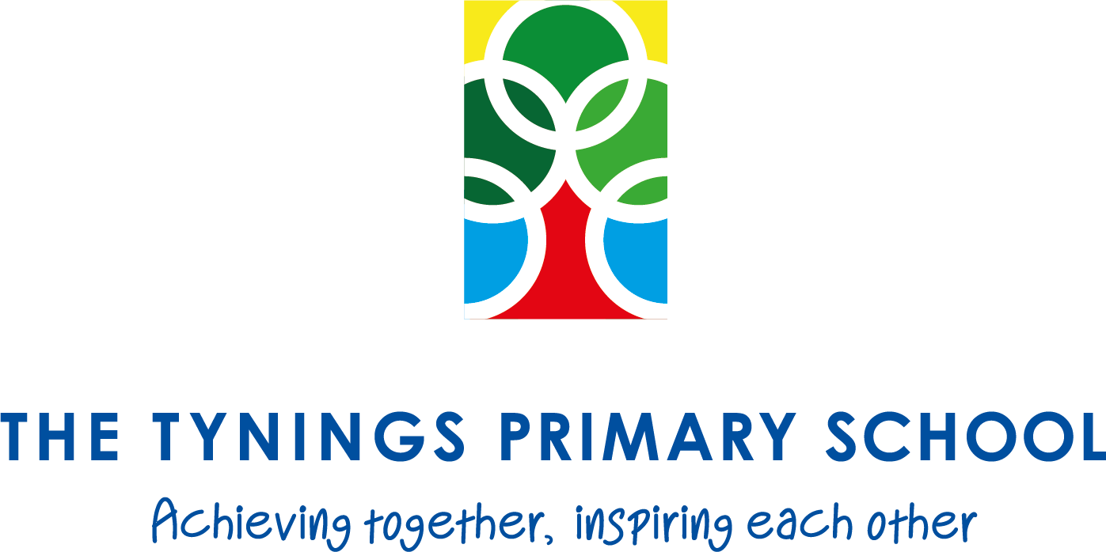

EYFS Teaching Assistant

Hours: Monday – Wednesday 8.30am – 3.30pm (18hrs p/w) TTO
Start date: 2nd November 2020
Salary: Grade H10 £8,537 p/a

The Tynings Primary School is a two form entry primary school based in Staple Hill, Bristol. We aim to provide a safe, happy, healthy learning environment in which our pupils can thrive.
We are looking to appoint an enthusiastic part-time (Monday to Wednesday) Teaching Assistant for November 2020 to assist our Early Years Team in creating a stimulating learning environment in which our youngest pupils can grow and develop. You will be joining a dynamic team of teachers and assistants who encourage children to explore the world around them.
The successful candidate should possess a Level 3 or above Early Education and/or Childcare qualification and have experience of working within an Early Years setting. Friendly and approachable, they will be able to develop good relations with the children, their parents, and staff, and fundamentally, should show that they care about children and their learning.

The school is committed to safeguarding and promoting the safety and welfare of children and young people. All staff and volunteers are expected to share this commitment and all appointments will be subject to appropriate vetting, including an enhanced DBS disclosure check.

Some roles may need to comply with the ‘Childcare Act 2006’ and the ‘Childcare (Disqualification) Regulations 2009’ where additional disclosure of information will be required.

